Name: ________________________________
Period: ____________
Design Yourself

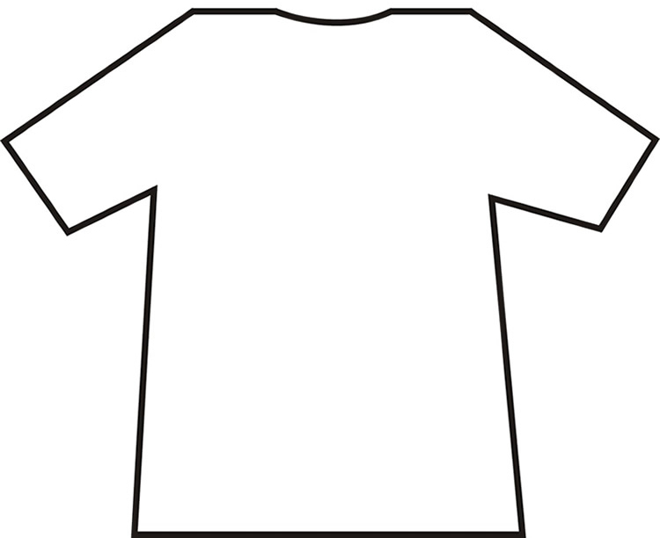
Instructions: Design a t-shirt that explains who you are. On your shirt you should draw your own personality, your hobbies, goals, future dreams, family dynamics, etc. Your shirt should be colored and neatly done. Be as creative as possible, these will be hung up in the classroom!

